MILESTONE ACADEMY
VACATION HOME WORK
CLASS-VIII
PC/MS/2019-20/VIII/050
--------------------------------------------------------------------------------------------------------------------
ENGLISH
- You are Councillor of Moti Nagar. Draft a notice, appealing to the people of the area, to minimise the wastage of water since the surrounding areas have been affected due to actual water shortage.
- You are Abhi. Leave a message for Gunjan warning her not to switch on the AC since for fuse might blow off.
- Cross word puzzle

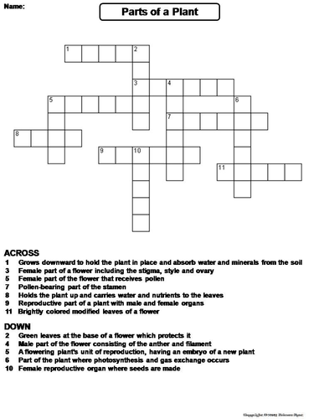
ACROSS
- Grows downward to hold the plant in place and absorb water and minerals from the soil
3. Female part of a flower including the stigma, style and ovary.
6. Female part of the flower that receives pollen.
7. Pollen bearing part of the stamen.
8. Holds the plant up and carries water and nutrients to the leaves.
9. Reproductive part of a plant with the male and female organs.
11. Brightly coloured modified leaves of a flower.

DOWN
- Green leaves at the base of a flower which protects it.
4. Male part of the flower consisting of the anther and filament.
5. A flowering plant unit of reproducton, having an embryo of a new plant.
6. Part of the plant where photosynthesis and gas exchange occurs.
10. Female reproductive organ where seeds are made.

GSC-
- In the month of August Kerala was hit by flood. Prepare a write up for the following.
- What all diseases are likely to be spread there?
- What precautions should be taken if there is meteorological alert for such disaster?
- What are the major causes of flood?
- Prepare a Project on “Adolescence”

MATHS-
1. Write about 4 different mathematicians and contribution towards Maths.
2. Draw different types of quadrilaterals in paper and write its formula for area and perimeter.

S.SC-
I. Chhattisgarh is your state dwelling. What are the things that fascinate you in this state. Why would
you like to live in the state life long.
2.Think and analyze :Paste pictures and write information in a project file.
“Gradual progress in the condition of women in our society. Select any three women from Indian History who inspire you. Make a report on their struggle and achievements. PTO
.

HINDI- 1- okD; ds fofHkUu vaxksa dks n'kkZb;sA
2- izkpk;kZ dks “kkys; Hkze.k esa lfEefyr gksus gsrq vkosnu i= fyf[k,A

SANSKRIT- 1- dkjd jpuk& jktu~] ;r~ ¼rhuksa fyaxks esa½
2- /kkrq :ikf.k &¼ijLeSin½] iwt~] j{k~] ik ¼fic½ [ ik¡pksa ydkjksa esa ]
¼vkReus in½ &yHk~] ;kp~] [ rhuksa ydkjksa esa ]
3- vuqPNsn ys[ku & ee fiz; f'k{kd%

COMPUTER-
Make project and submit hard copy and soft copy
Q1. Write down HTML code to generate the following result.
(i) Set its title as order lists and unorder lists (ii) Set the bgcolor of page to blue.
(iii) Create the heading as order and unorder lists using the font size =‘10’ font face = ‘Home word Bound and color = ‘Red’
Out Put

Order list and unorder list
- General Science
1. Physics
2. Chemistry
3. Biology
- Social studies
4. History
5. Civics
6. Geography

LIFE SKILLS
CLASS – VIII
This activity will enable students to understand story narrative in terms of life skills

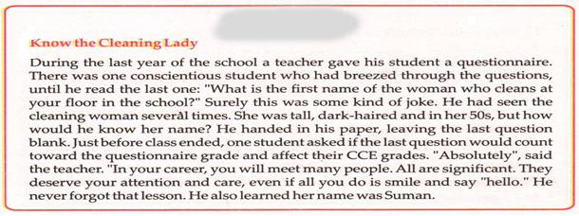

Now answer the questions about the story
- What is your learning from the story?
- What are the life skills involved in this narrative?
- Write down the names of 25 peoples, who have influenced you in your life.

SUBMISSION DATE-31/10/19
200

